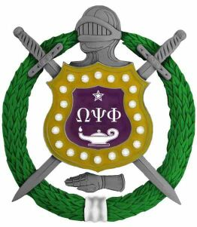
The Rev. Dr. Joseph Rice 2017 Talent Hunt Program
November 17, 2016
From: Omega Lambda Lambda Chapter
Omega Psi Phi Fraternity, Inc. Madison,/Hendersonville, TN

To Whom It May Concern:

Omega Psi Phi Fraternity, Inc. since its inception in 1911 has strived to develop young people into success, either through scholarship or through the pursuit of the fine arts. Beginning in 1953, Omega Psi Phi Fraternity has sponsored its annual Talent Hunt Program for those young people in grades 9-12 and having some interesting in the arts, whether through singing, dancing, oration, or instrumental performance. This program provides exposure, encouragement, and financial assistance to talented young people. In the past, participants at the national level have been awarded college scholarships.
The Rev. Dr. Joseph Rice, as a members of the Fairfield Four are best known from their appearance on the soundtrack and on screen in the Coen Brothers 2000 film, O Brother Where Art Thou. They are multiple Grammy winners with albums including Standing in the Safety Zone (1992) and I Couldn't Hear Nobody Pray (1997) on Warner Brothers, Wreckin' the House (1998) on Dead Reckoning, The Fairfield Four and Friends Live from Mountain Stage (2000) on Blue Plate, and by their bass singer Isaac Freeman with the Bluebloods, Beautiful Stars (2003) on Lost Highway. Continuing in this great tradition, we are proud to announce the 2017 Talent Hunt Competition! We are soliciting all interested participants for auditions.
The individual selected will be performing and competing in our Rev. Dr. Joseph Rice Talent Hunt Competition for cash, prizes, and possible scholarships. The Talent Hunt Program will be held on Saturday: February 18, 2017, at 1021 Russell Street, Nashville, TN. 37206. All friends, family and well-wishers are urged to come and show their support. Please contact Bro. Charles Hopkins at 615-568-6356, Bro. Melvin Miller at 615-587-3362, Bro. Charles Wilson at 615-294-1720 Bro. Greg Greer at 615-497-1865 or Bro. Preston Bailey at 615-586-6441 for applications and other questions. Please encourage your youth to come and display their talents.

Sincerely,

Rev. Dr, Joseph Rice, Chair
Omega Lambda Lambda Chapter
Omega Psi Phi Fraternity, Inc.

